**Welcome to ACMA**



**About ACMA – American Case Management Association**

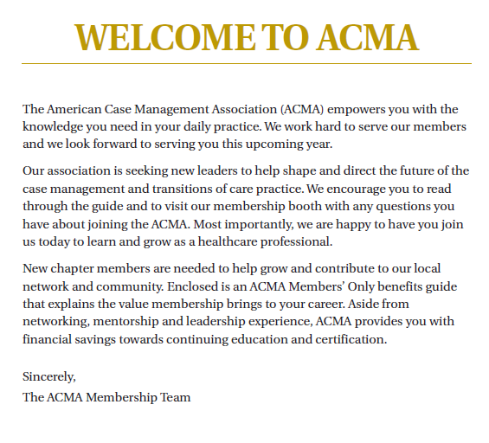

**American Case Management Association**

11701 West 36th Street,  Little Rock, AR  72211

Phone: 501-907-2262.   Fax 501-227-4247. Website:  <http://www.acmaweb.org/>

**CEO: L. Greg Cunningham**

**Director of Product and Services Development: Randall Archer**

**Director, Chapter and Meeting Services: Sandy McFolling**

**Director of Sales and Business Development: Becky Nations**

**Director of Marketing: Greg Petree**

**Director of Finance and Account Management: Maria Velasco**

**Director of Human Resources: Mark Williams**

**Mission**: To be THE Association for Health Care Delivery System Case Management and Transitions of Care (TOC) Professionals. (Approved April 11, 2013)

**Goals:** 1. Provide innovative professional development services:

* Mentoring
* Educational Forums
* Resource Information

2. Create new opportunities for networking.

3. Influence the policies, laws and other issues related to the practice of Case Management.

**Definition of Case Management**: The ACMA’s official definition of Case Management as approved by our membership in November of 2002 is as follows:

“Case Management in Hospital / Health Care Systems is a collaborative practice model including patients, nurses, social workers, physicians, other practitioners, caregivers and the community. The Case Management process encompasses communication and facilitates care along a continuum through effective resource coordination. The goals of Case Management include the achievement of optimal health, access to care and appropriate utilization of resources, balanced with the patient’s right to self-determination.”

**Welcome to the Wisconsin Chapter**



<http://www.acmaweb.org/net/chapter_site.aspx?eID=1518&chid=18>

Chapter Information:

* The Wisconsin Chapter of the ACMA was established in 2005.
* Your chapter represents Case Management professionals (RNs and SWs) who reside or work in the state of Wisconsin.
* Yearly Dues are included with ACMA membership.
* Bi-annual

**Chapters:**

ACMA Chapters provide enhanced networking and educational opportunities. Chapters provide a network of peers within your local or regional area, and host educational events periodically. Each chapter also hosts an Annual Chapter Conference that brings national level speakers to the chapter’s area.

Note: You must be an ACMA National member to join a chapter. However, you may join ACMA without having a specific chapter affiliation.

**Your Board of Directors:** (Executive Board is President, President Elect, Secretary and Treasurer)

**President:** Jessica Hertig, MSN, RN, ACM [jessicahertig@gmail.com](mailto:jessicahertig@gmail.com) 414-430-1549

**President Elect:** Bonnie Nierenhausen, CSW, ACM [Nierenhausen.bonnie@mayo.edu](mailto:Nierenhausen.bonnie@mayo.edu) 715-838-3472

**Secretary:** Joan Brueggeman, RN, BSN, CPUM, ACM [jebruegg@gundersenhealth.org](mailto:jebruegg@gundersenhealth.org) 608-775-5494

**Treasurer:** Carol Hennessy RN, ACM [carolhennessy@live.rog](mailto:carolhennessy@live.rog) 262-510-4086

**Member at Large:** Barb Huges [barb.hughes@outlook.com](mailto:barb.hughes@outlook.com) 414-750-7801  
**Member at Large:** Vickie VandenHeuvel, RN, BSN ACM [Vickie.vandenheuvel@aurora.org](mailto:Vickie.vandenheuvel@aurora.org) 262-329-

3429  
**Member at Large:** Kathleen Borchard [kborchard@gmail.com](mailto:kborchard@gmail.com) 262-391-7671

**Member at Large:** Laurie Sasso MSW [sassoinvestments@prodigy.net](mailto:sassoinvestments@prodigy.net) 262-424-2445

**Member at Large:** Dr. Juliet Ugarte Hopkins [Juliet.UgarteHopkins@phci.org](mailto:Juliet.UgarteHopkins@phci.org) 262-928-7802

**Chapter Mentor:** TBD (used to be called the National Board Liaison position)

**ACMA Manager of Chapter Relations**: Holly McWilliams [hmcwilliams@acmaweb.org](mailto:hmcwilliams@acmaweb.org) 501-907-2262

**Past President:** Kristen Strother [Kristen.strother@aurora.org](mailto:Kristen.strother@aurora.org) 414-219-4535

**Membership Chair:** Bonnie Nierenhausen **Chapter Website Administrator:** Jessica Hertig

 [**Wisconsin Chapter of the American Case Management Association**](https://www.facebook.com/WisconsinChapterACMA/)

[**https://www.facebook.com/WisconsinChapterACMA/**](https://www.facebook.com/WisconsinChapterACMA/)

[](https://www.facebook.com/1001713089866281/photos/1122855541085368/) **Like us on Facebook**

**2016 conference with some of our board members and committee members.**

**Chapter of Merit**

Our chapter received the designation of Chapter of Merit at the ACMA National conference in Washington D.C (April 2017). This is the first time in our 11 year history that we accomplished this! We were 1 of 4 chapters to receive this recognition. This is an amazing accomplishment that took a lot of work from our entire board.

Bonnie, Jessica and Dan were present to accept this award for the ACMA WI Chapter. Thanks to the board and to all of you for making this accomplishment happen!



**Benefits of ACMA Membership**

Per the 2016 ACMA Member Satisfaction Survey, the number one reason members return to ACMA year after year is to advance their career. Many members that receive job promotions say that ACMA membership is a significant factor in their advancement or promotion. The tools and resources provided by ACMA are designed specifically to help advance your career.

**Membership Benefits The ACMA Member Advantage**

Whether you are just beginning your case management career, or have served for years in the profession, ACMA membership can help you take the next step in your career. ACMA membership provides free CE-activities, up-to-date news on health care topics, advocacy, community forums, resources for professional growth, exclusive discounts…and much more.

Find out why ACMA is the organization for health care delivery system case management and transitions of care professionals – [**join ACMA today!**](http://www.acmaweb.org/join)[**https://www.acmaweb.org/net/join.aspx?sID=4&mn=mn7&sn=sn7&wpg=join**](https://www.acmaweb.org/net/join.aspx?sID=4&mn=mn7&sn=sn7&wpg=join)

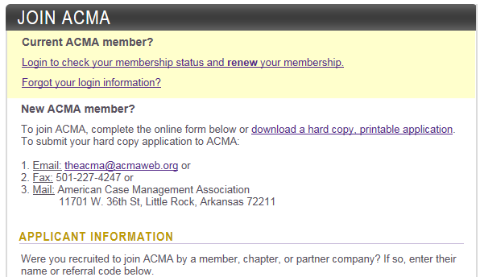

**Members' Only Resources**

According to the 2016 ACMA Member Satisfaction Survey, the number one reason members return to ACMA year over year is to advance their career. Many members that receive job promotions say that ACMA membership was a significant factor in their advancement or promotion. The tools and resources provided by ACMA are designed specifically to help advance your career.

**LEARNING LINK – Connect with the Entire ACMA Membership**

Join the conversation and find solutions to the latest challenges case management professionals face by connecting with the most active online case management community in the United States. Members can view past discussions, download tools and resources, and connect with more than 6,600 leaders in the case management field.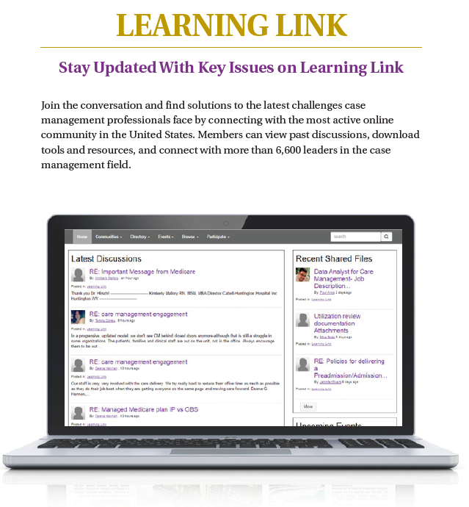

**ONLINE CE Center- Easily Acess 35 hours of FREE CE’s**

Gain free access to educational activities designed to help achieve professional growth and excellence in clinical practice. Members have more than 30 hours of complimentary online CE at their fingertips through video webinars or Collaborative Case Management articles. This benefit alone is worth upwards of $1,200 - [**learn more!**](http://www.acmaweb.org/files/Online_CEs.pdf)[**http://www.acmaweb.org/files/Online_CEs.pdf**](http://www.acmaweb.org/files/Online_CEs.pdf)

***Free Online CEs In Members Only Section***

*Login at: Acmaweb.org/login

*Click the CE Center tab and then choose between Video Webinars and Publications

*After watching a video webinar or reading the publication you can take a short quiz to earn 1 CE

*Locate your certificates for CEs by clicking the CE Activity link and then clicking the “Certificate” button

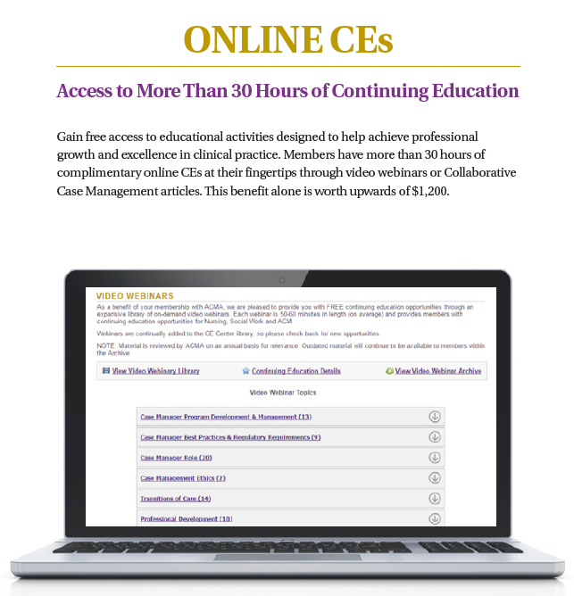

**POLITICAL ADVOCACY- Participate in the Legislative Process**

Take part in making a lasting difference! ACMA is the voice for case management on political issues. Members can participate in continuous, proactive advancements for their practice and contribute to expert health leadership – [**learn more!**](http://www.acmaweb.org/section.aspx?sID=88)[**http://www.acmaweb.org/section.aspx?sID=88**](http://www.acmaweb.org/section.aspx?sID=88)

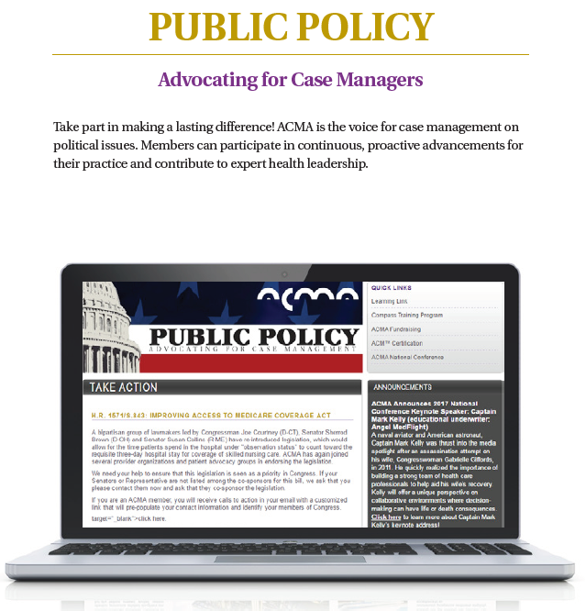

**COLLABORATIVE CASE MANAGEMENT-Read Articles Focused on Your Industry**

Receive six issues annually of Collaborative Case Management – ACMA’s peer-reviewed journal focused on industry best practices. Articles focus on solutions to current industry issues, successful strategies for practice, innovative patient interventions and the education needed by health care case managers to enhance their practice. Through this publication, ACMA continues its commitment to supporting the evolving practice of Hospital/Health System Case Management.

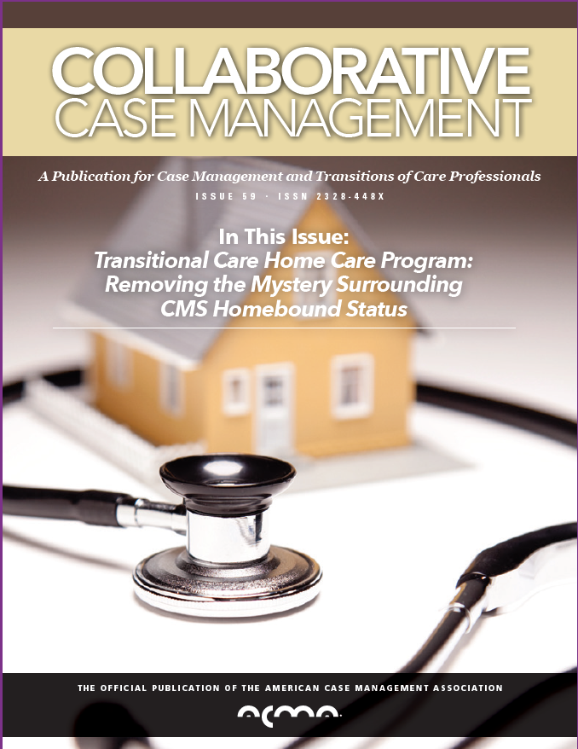

**NATIONAL HOSPITAL CASE MANAGEMENT SURVEY-The Only Survey Data Available**

Access ACMA’s evidence-based benchmarking resource for hospital/health system case management. The survey includes data on over 75 elements of practice at a 95% confidence level and is used by both members and organizations in supporting their practice. Survey results are only available in the Members’ Only section of the site – [**learn more!**](http://www.acmaweb.org/section.aspx?mn=&sn=&wpg=&sid=23)[**http://www.acmaweb.org/section.aspx?mn=&sn=&wpg=&sid=23**](http://www.acmaweb.org/section.aspx?mn=&sn=&wpg=&sid=23)

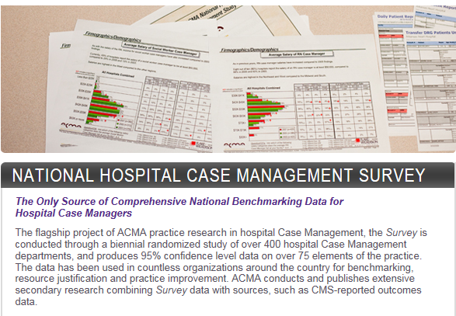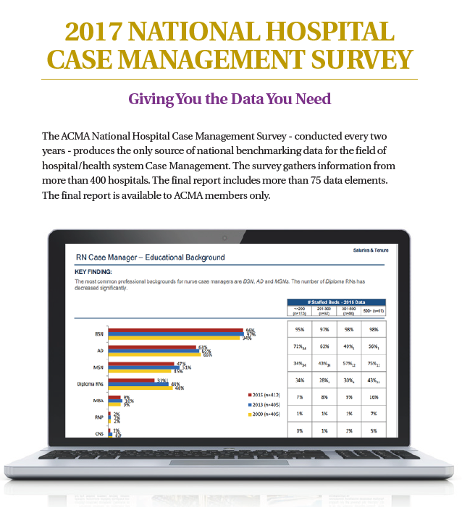

**Educational Event and Product Discounts-Receives discounts on ACMA Products**

Receive discounts to ACMA’s year-round educational conferences. Events are available to all case management professionals, but members receive registration discounts to all chapter and national conferences – [**learn more!**](http://www.acmaweb.org/map.aspx)[**http://www.acmaweb.org/map.aspx**](http://www.acmaweb.org/map.aspx)

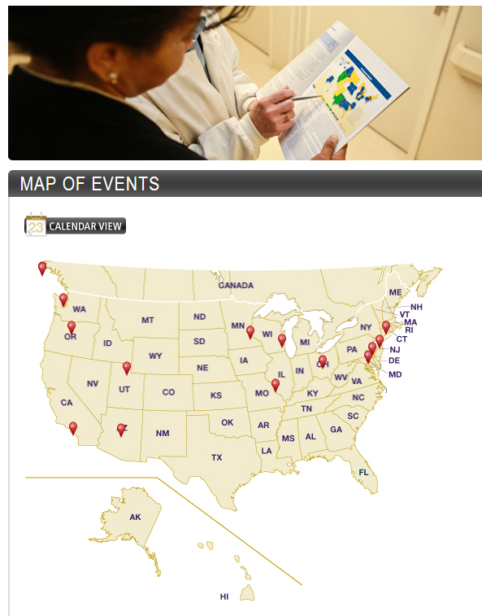

Additionally, members receive significant savings on annual [**Compass Directional Training**](http://www.acmaweb.org/compass),

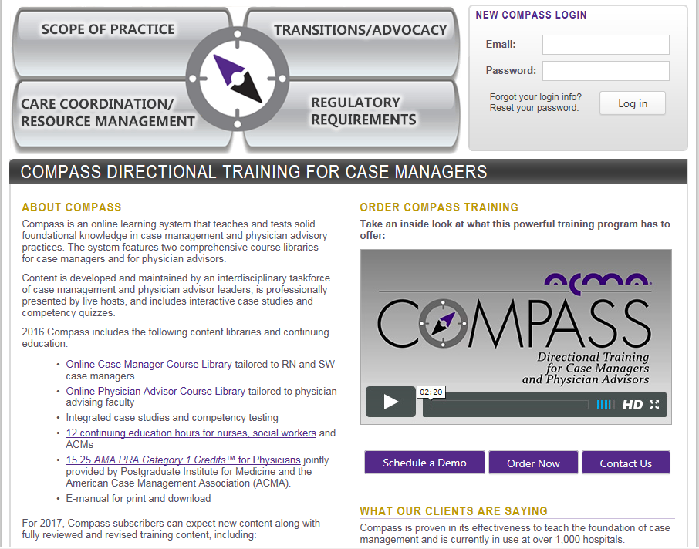

<https://www.acmaweb.org/compass/compass_main.aspx>

[**ACM Certification Study Guide**](http://www.acmaweb.org/study_guide/default.aspx)

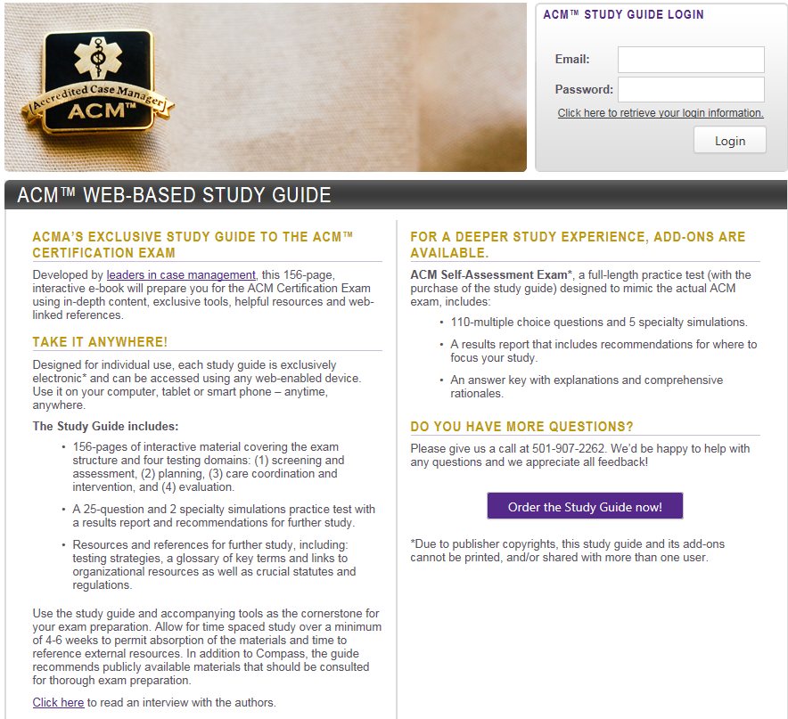

<http://www.acmaweb.org/study_guide/default.aspx> and other products exclusive to ACMA.

**MEMBER DISCOUNT PROGRAM-Save Money on Everyday Purchases**

Enjoy savings from nationally recognized retailers, travel and finance companies through ACMA’s Abenity discount program. ACMA members have access to thousands of discount and savings opportunities from companies such as Sprint, Firestone, Restaurant.com, Target, Office Depot, Walt Disney World, and many more. Offset your membership investment by saving on every day purchases – [**learn more!**](http://www.acmaweb.org/files/membersavingscalculator.pdf)[**http://www.acmaweb.org/files/membersavingscalculator.pdf**](http://www.acmaweb.org/files/membersavingscalculator.pdf)



**MEMBER DISCOUNT PROGRAM: SAVINGS CALCULATOR**

Your ACMA Member Discount Program powered by Abenity gives you access to thousands of national and local discounts. But did you also know it increases your spendable income and that the money you save will more than cover the cost of your ACMA membership dues?

Below are examples of current and previously offered discounts. Log into the member-only section of ACMA’s website to begin shopping…saving…and earning cash back!

|  |  |
| --- | --- |
| **Discount Offer Estimated Savings FIRESTONE COMPLETE AUTO CARE**  5% Off Oil Changes And Auto Repair 4 oil changes costs $120, plus add in one $300 auto repair. With the discount, you save $63 annually. | **$63.00** |
| **SPRINT**  15% Off Monthly Rates For New And Existing Accounts The monthly wireless bill for a family of 4 can easily reach $120. Take off 15% and you save up to $216 annually. | **$216.00** |
| **RESTAURANT.COM**  Save 60% on Gift Certificate Purchases Purchase $25 gift certificates everyday for $7.50 everyday, accepted at over 18,000 participating restaurants. Purchase four gift certificates and you save $70. | **$70.00** |
| **MOVIE TICKETS**  Discounts From Over 15 Theaters Nationwide Save up to 40% off movie tickets from over 15 theaters nationwide. If you buy 8 movie tickets in a year, you save over $20. | **$20.00** |
| **OFFICE DEPOT**  Save 15-30% on Select Home Office Supplies Save 15-30% on select home office supplies, including paper, toner, ink cartridges and more. Spend $200 annually and save $50. | **$50.00** |
| **WALT DISNEY WORLD**  10% Off Park Passes A three-day admission ticket to 4 parks costs $289/ticket, but you save 10%. If you buy 4 tickets at $267/ticket, you save $124. | **$124.00** |
| **ABENITY TRAVEL CENTER**  Hotel Savings Nationwide Travelers average $30 in savings per night. If you spend 3 nights in a hotel annually at one of 60,000 participating locations, you save $90. | **$90.00** |
| **ABENITY TICKET NETWORK**  10% Off Tickets To Concerts & Sporting Events Savings at over 20,000 concerts and events. Attend 3 events annually and you save over $50. | **$50.00** |
| **DELL**  Save up to 30% on Systems from Dell Tremendous savings on computers, gaming devices, MP3 players, HDTV home theaters and so much more. Average savings of $150 on new laptops. | **$150.00** |

**BRIEFCASE**

Stay informed with ACMA’s briefCASE – a weekly summary of professional and industry news. Get what you need to know emailed to you every week, including new legislative and research news, as well as ACMA updates, information

**ArchiTools**

Launch a case management-specific web resource for improving value-driven health care. Developed by Pfizer, ArchiTools is a evolving resource that provides a comprehensive information and tools, such as interactive training modules, action tools that can be downloaded and used with patients, annotated articles and a robust set of relevant external links – [**learn more!**](http://www.acmaweb.org/section.aspx?sid=133)[**http://www.acmaweb.org/section.aspx?sid=133**](http://www.acmaweb.org/section.aspx?sid=133)

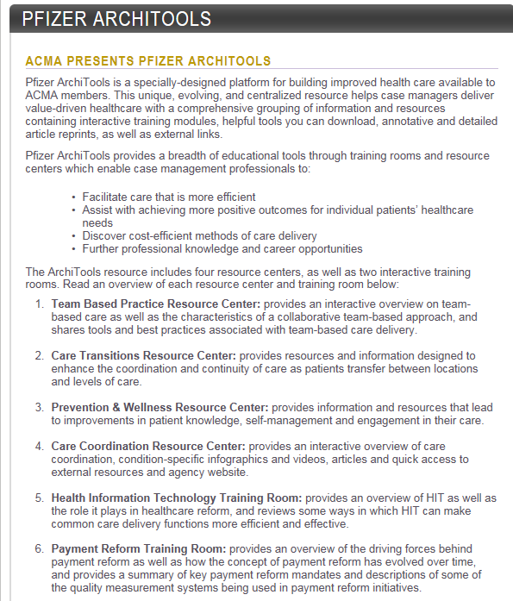

**Benefits of ACMA Membership by the Numbers**

**35**: Over 35 hours of FREE online containing education

**6,300:** Connect with 6,300 active colleagues in your membership network in person or online through our Learning Link ListServe

**75:** Key case management metrics in ACMA’s national research – The finds from more than 400 hospitals are organized into 1 report for our members only!

**52:** Issues of our E-Newsletter, briefCASE, covering the latest happenings in Case Management and Transition of Care.

**6:** Issues of Collaborative Care Management – our peer reviewed journal.

**Hundreds:** Save on things you buy every day with the members discount program or use your membership number to save on events and many of ACMS’s complementary products.

ACM Certification for Health Care Delivery System

Case Management Professionals

The ACM Certification is designed specifically for health care delivery system case management professionals. This certification is unique among case management certifications, utilizing clinical simulation testing methodology to test “competency beyond knowledge” by evaluation critical thinking skills and the ability to use knowledge in practical situations.

Over half of all hospitals / health care delivery systems prefer the ACM certification. You can learn more at [www.acmaweb.org/ACM](http://www.acmaweb.org/ACM)

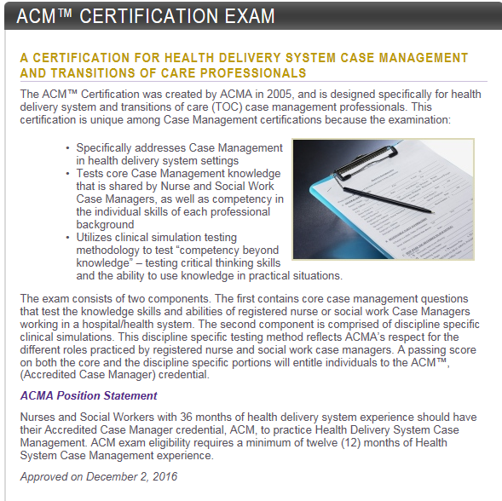

# Roles and Responsibilities of Chapter Board Members

The governing responsibilities of chapter board members are defined within the context of their chapter bylaws. Chapter Board Members are required to be current ACMA National and Chapter members.

|  |  |  |  |  |
| --- | --- | --- | --- | --- |
| The Chapter Advisory Council (CAC) has developed orientation programs to assist chapter officers with understanding their roles and responsibilities as president, president-elect, secretary and treasurer.  **President Responsibilities**   1. **Communications**   All public statements on behalf of the chapter must be consistent with National ACMA' s official position. If ACMA's position is not known, or if it is a new or controversial matter, Chapter President has the responsibility to seek advice from ACMA CEO or National President. It is also the responsibility of National ACMA to keep Chapters informed of any ACMA National official position statements.  It is also the responsibility of the Chapter President to keep Chapter Board Members informed of any ACMA National operations, activities and correspondence (i.e, correspondence from ACMA National, Chapter President Meetings, and reaffirm national communications to all members).   1. **Appointment Duties**   Chapter Presidents shall make the appointment for the following:  **Committees:**  Chapter Presidents shall appoint chairs for two (2) of the four (4) committees specified in the Chapter's bylaws: Education Committee and Membership Committee. The current Chapter President serves as chair of the Executive Committee and the Immediate Past President serves as chair of the Nominating Committee.  Appointments should be made for a specific term (i.e. 1 year, 2 year, etc) as determined and approved by the Chapter Board and in writing to the appointee. It is typical that appointments do not exceed one year, and cannot overlap into another President's term. For President' s who hold two terms it is advisable that appointments are made for one year terms and renewed for the second year based on successful performance.  **Board Position Vacancies:**  The Chapter President shall appoint, with Chapter Board approval, a full member in good standing to complete the un-expired term. Appointment should occur within 30 days of resignation or removal.   1. **Meeting Attendance**   Another responsibility of the Chapter President is meeting attendance. It is imperative that the Chapter President attend all meetings.  The following are the specific meeting responsibilities of the Chapter President:   1. Attend and preside at Chapter Board Meetings and Member Meetings. If either the President or President-elect is unable to attend a meeting, the Chapter President should appoint another Chapter Board Member to represent the Chapter. 2. Preside at the Chapter's annual business meeting. 3. Prepare and distribute an agenda for all meetings, even if there is very little business. 4. If the Chapter Secretary cannot be present to take minutes, the President should appoint a suitable substitute. 5. Meeting attendance should be recorded in the board minutes. There is a Minutes Template in the ACMA Chapter Manual. 6. **Reporting Duties**   The Chapter President must submit several specific reports that are due at predetermined times during the Associations' business year. These reports must be submitted on or before the stated deadlines, regardless of which Chapter Board Member or committee chair has the responsibility for preparation and distribution of the report. For summary chart go to [Section 15: Reporting to National](http://www.acmaweb.org/chaptermanual/section15.htm) of the Chapter Manual.   1. **General Duties**   There are several general duties that are crucial to the successful operation of the Chapter and to the smooth transitions of authority. Among the general duties of the Chapter President are the following:   1. Understand and communicate to the Chapter Board the information contained   within these Chapter Guidelines and the Chapter Bylaws.   1. On assuming office, acquire from the past President the records, current unresolved                               issues list and any history necessary to fulfill the role. (If chapter records are not                               received within 30 days, contact the departing President to request their transfer)  [P&P: Document Retention and Destruction](http://www.acmaweb.org/chaptermanual/attachments/Section%204%20&%209%20&%2010_P&P_Document%20Retention%20and%20Destruction_revised.pdf) in the Chapter Manual.   1. Facilitate final decisions by the Board or Executive Committee on the operation of the Chapter. 2. Assist the Chapter Board of Directors in formulating policy, directing Chapter operations, formulating procedures and programs. 3. Prepare the [Annual Budget](http://www.acmaweb.org/chaptermanual/attachments/Section%204_AnnualChapterBudgetTemplate.doc) of the Chapter for approval of the Chapter Board and the ACMA. 4. Serve, during the chapter's first year, as the Chair of the Nominating Committee. Thereafter, Past-President serves in this capacity. 5. At the conclusion of term as Chapter President, review with the President-elect the responsibilities of the position and any ongoing projects. 6. On retiring as Chapter President, forward all current records to the incoming President within 30 days of stepping down from office. 7. For expeditious decision making and in the absence of a full board meeting, the President can utilize the Executive Committee to make a decision and at the next full board meeting must review that decision with the Board and ensure that it is ratified (this is confirmation by the full board that you have informed them of the decision and that they concur). 8. Ensure the budget is established and adhered to for the chapter. 9. Ensure the annual meeting is planned for the members’ best interest and to successfully achieve attendance and profitability for the meeting. 10. Attend bi-annual Chapter Presidents Meetings. If unable to attend, President can appoint representative to attend on their behalf.   Previous Chapter Presidents, Lois Cross (No Cal), Charleeda Redman (WPA) and Patricia Thomas (Great Lakes) created a helpful tips sheet for new Chapter Presidents transitioning to the role and planning for success. To downloadthe ***Tips for A New ACMA Chapter President*** go to your Chapter Manual on line .    **President-elect Responsibilities**  **General Duties**  The following duties are essential for the efficient operation of the Chapter and for the smooth transition of office:   1. Review and understand the President's responsibilities as outlined in these guidelines and the chapter bylaws. 2. Substitute for the Chapter President. The President-elect may act in the President's absence and perform other duties as required or as provided for in the Chapter's bylaws and/or procedures manual. 3. Attend meetings. The Chapter President-elect is required to attend the same meetings as the Chapter President. These are detailed under the Chapter President's responsibilities of these guidelines. 4. Perform any other duties as assigned by the Chapter President. It is recommended that you review your Chapter Bylaws for specific duties that may not be covered in the above description. 5. Learn during their term, the interworking of the chapter and ensure they understand the role, chapter history, board meeting planning and preparation, annual meeting planning, and budgeting. 6. Attend the bi-annual Chapter Presidents Meetings. If President and President-elect are unable to attend, President can appoint representative to attend on their behalf.   **Secretary Responsibilities**  The Chapter Secretary maintains all records with the exception of financial records for the Chapter.  **General Duties**   1. Facilitate notice of all meetings to membership. 2. Conduct official correspondence and maintain a file of current records. Chapter records should include meeting minutes, membership database, vendor database, and local contact database. [P&P: Document Retention and Destruction](http://www.acmaweb.org/chaptermanual/attachments/Section%204%20&%209%20&%2010_P&P_Document%20Retention%20and%20Destruction_revised.pdf) in the on line Chapter Manual. 3. Record and distribute minutes of all Chapter Board Meetings and Member Meetings within 30 days of the meeting. Minutes are a record of the proceedings of all meetings and should include an accurate description of the topics discussed and decisions made. To download a Minutes Template go to the Chapter Manual.   For items requiring a Board vote, the following should be recorded in the minutes:   * 1. the wording of each motion   2. the person making the motion   3. the second to the motion   4. whether the motion was approved, failed or tabled for future discussion   5. nature of the vote: unanimous, 5 to 3 etc and noting anyone abstaining from the vote  1. Prepare one copy of the approved minutes within 60 days from the meeting for chapter records after the minutes have been approved, signed/dated by the Secretary and President. 2. Ensure that chapter business records are properly filed. [P&P: Document Retention and Destruction](http://www.acmaweb.org/chaptermanual/attachments/Section%204%20&%209%20&%2010_P&P_Document%20Retention%20and%20Destruction_revised.pdf) in the Chapter Manual. 3. Verify that all chapter reports are completed and the appropriate reports are sent to ACMA National Office within the timeframe designated. 4. Submit a [Chapter Leadership Contact Form](http://www.acmaweb.org/chaptermanual/attachments/Section%204_ChapterLeadershipContactForm.xlsx) (in the Chapter Manual) to ACMA National within thirty (30) days of election/nomination. 5. Transfer records to the new Chapter Secretary. On assuming the office of Secretary, all Chapter records should be given to the incoming Chapter Secretary within thirty (30) days of stepping down from office.   **Treasurer Responsibilities**  The Chapter Treasurer maintains all financial records for the Chapter.  **General Duties**   1. Have charge of all funds and securities of the Chapter. 2. Keep a full and correct account of receipts and disbursements in the records of the Chapter. 3. Deposit all monies in the name and to the credit of the Chapter in such banks of deposit as may be designated by the Chapter Board of Directors. 4. Render to the President and the Chapter Board of Directors, whenever they may require it of his or her, an account of all his or her transactions as Treasurer and of the financial condition of the Chapter. 5. Collect, deposit and expend funds for the Chapter as requested and authorized by the President. 6. Audit monthly membership dues submitted to Chapter by ACMA National (if applicable). For more information go to [Section 9: Chapter Finances](http://www.acmaweb.org/chaptermanual/section9.htm) (in the Chapter Manual). 7. Maintain Chapter financial records in a complete and accurate method. The treasurer should balance the accounts each month and ensure that all documentation for income and disbursements is kept in order. 8. Report any financial information or financial statements as requested by the ACMA National Office. For summary chart go to [Section 15: Reporting to National](http://www.acmaweb.org/chaptermanual/section15.htm) (in the Chapter Manual). 9. Maintain financial records. [P&P Document Retention and Destruction](http://www.acmaweb.org/chaptermanual/attachments/Section%204%20&%209%20&%2010_P&P_Document%20Retention%20and%20Destruction_revised.pdf) (in the Chapter Manual). 10. Ensure that all Chapter bank account signatures are changed to the newly elected President and Treasurer. Bank accounts must have two (2) approved signors (President and Treasurer). 11. Transition all financial records for the Chapter to the incoming Treasurer within 30 days of completed term. 12. Work with Chapter President to create an [Annual Budget](http://www.acmaweb.org/chaptermanual/attachments/Section%204_AnnualChapterBudgetTemplate.doc).     **Member-at-Large Responsibilities**  **General Duties**   1. Assist and support the officers of the Chapter in all aspects of Chapter planning and development. 2. Attend all meetings. 3. Serve on committees as appointed by Chapter President. 4. Ensure compliance with the bylaws and proper procedures of governance. 5. Represent the membership that elected them and ensure the priorities, resource allocations and leadership do so with the best interest of the membership.   **Chapter Committees**  As outlined in Section VII of ACMA Chapter Bylaws, each chapter is required to have four (4) standing committees: Executive Committee, Nominating Committee, Membership Development Committee, and Education Committee. The Chapter Board of Directors may designate other committees to aid and assist the Board in the management of the affairs of the Chapter.    All actions taken and recommendations made by committees shall be advisory and shall have no effect as actions of the Chapter unless they are formally approved and adopted by the Chapter Board of Directors.      **Executive Committee**  The Executive Committee is comprised of the President, President-Elect, Secretary and Treasurer.  If the offices of Secretary and Treasurer are combined into one office, the President can annually, upon their election, appoint one additional Board member to the Executive Committee.    The Executive Committee may act on behalf of the chapter in any matter when the Board of Directors is not in session, reporting to the Board within thirty (30) days of the action, or at the next meeting of the Board, whichever comes first.  At least three (3) members of the Executive Committee must be present to constitute a quorum.  The President or in the absence of the President, the President-Elect can call a meeting of the Executive Committee.  The Executive Committee shall have the Treasurer’s accounts reviewed at least once each calendar year, and report thereon to the Board.  **Nominating Committee**  The Chapter President is to appoint, subject to the approval of the Chapter Board of Directors, a Nominating Committee whose function is to solicit, screen and submit potential candidates for members of the Chapter Board of Directors and Officers.    The Immediate Past President serves as the Chair of the Nominating Committee.  At least three months prior to the date of the Chapter’s Annual Session, the Chapter Nominating Committee is to seek, receive, prepare nominations and propose a slate of candidates to the Chapter Board for approval.  The Chapter is then responsible for preparation, distribution, collection and counting of the ballots. For more information regarding Chapter Elections go to [Section 5: Chapter Elections and Appointment](http://acmaweb.org/chaptermanual/section5.htm)      **Membership Development Committee**  The Chapter President is to appoint, subject to the approval of the Chapter Board of Directors, a Membership Development Committee whose function is to develop recruitment and retention strategies for the Chapter membership, identify member needs and communicate these to the Chapter Board, and annually develop membership goals and objectives.      **Education Committee**  The Chapter President is to appoint, subject to the approval of the Chapter Board of Directors, an Education Committee whose function is to annually plan and present a minimum of eight (8) hours of approved continuing education credits for nurses and social workers.  Conflict of Interest / Code of Ethics    **Conflict of Interest**  Chapter Board of Directors are expected to disclose situations that may present potential conflicts of interest. All directors, and, committee members with board delegated powers, must annually complete a [Conflict of Interest Disclosure](http://www.acmaweb.org/chaptermanual/attachments/Section%204__ACMAChapterBoardConflictofInterestDisclosure.pdf) (in the Chapter Manual) which indicates/lists all financial and potential conflicting interests and any material facts, relating to those interests. Completed disclosure statements will be submitted to, and maintained by, ACMA's National office. [P&P: Conflict of Interest](http://www.acmaweb.org/chaptermanual/attachments/Section%204_ACMA%20Governing%20Policy%20-%20Conflict%20of%20Interest%20_approved_.pdf) (in the Chapter Manual).  **Code of Ethics**  Chapter Board of Directors are also expected to annually submit a signed [Code of Ethics](http://www.acmaweb.org/chaptermanual/attachments/Section%204_ACMAChapterBoardCodeofEthics.pdf) (in the Chapter Manual) and comply with the Code of Ethics & Standards of Conduct for Chapter Board of Directors of the American Case Management Association.  **Notes:** | |  | | --- | | [Policy       Handbook](http://www.acmaweb.org/chaptermanual/index.html) | | [Table       of          Contents](http://www.acmaweb.org/chaptermanual/toc.html) | |  |   http://www.acmaweb.org/chaptermanual/empty.gif |
| http://www.acmaweb.org/chaptermanual/gline.gif | |